

THEORY ASSIGNMENT 1

WRDA YOUSAF

SP23-BSE-042

TRANPORT MANAGEMENT SYTEM

USECASE LOGIN

FULLY DRESS USECASE

|  |  |  |  |  |  |  |
| --- | --- | --- | --- | --- | --- | --- |
| |  |  | | --- | --- | |  |  |  |  |  | | --- | --- | | **User Login** | | |  | | UC-1 |
| |  |  | | --- | --- | | **Use Case Name** |  | | |  | | --- | |  |  |  | | --- | | User Login | |
| |  | | --- | | **Actor** |  |  | | --- | |  | | |  | | --- | |  |  |  | | --- | | End User (Customer) | |
| |  | | --- | | **Trigger** |  |  | | --- | |  | | |  | | --- | |  |  |  | | --- | | User navigates to the login page and clicks the login button after entering credentials | |
| **Description** | This use case allows a registered user to log into the Transport Management System using valid credentials. |
| **Preconditions** | * User must be registered in the system * User has valid login credentials (email/username and password) |
| **Postconditions** | * **Success**: User is logged in and redirected to their dashboard. * **Failure**: User remains on the login page and receives an error message |
| |  | | --- | | **Normal Flow** |  |  | | --- | |  | | 1. User navigates to the login page. 2. System displays the login form. 3. User enters email/username and password. 4. User clicks the “Login” button. 5. System validates the credentials. 6. If valid, system logs in the user and redirects to the dashboard. |
| **Alternative Flow** | **A1: Forgot Password** 1. User clicks on “Forgot Password”. 2. System prompts for the registered email. 3. User enters email. 4. System sends password reset link. 5. User resets password and logs in with the new one |
| |  | | --- | | **Exception Flow**  **Baseness Rules** |  |  | | --- | |  | | |  | | --- | |  |  |  | | --- | | **E1: Invalid Credentials** 1. User enters incorrect email or password. 2. System displays: "Invalid username or password."  **E2: Account Locked** 1. User fails login 3 times. 2. System locks account for 15 minutes and displays: Account temporarily locked due to multiple failed login attempts.  BR-01 Password must be at least 8 characters, contain letters and at least 1 digit.  BR-02 Aafter 5 failed login attempts, account is locked for 15 minutes  BR-03 Only registered users can access login functionality. | |
| **Assumptions** | |  | | --- | |  |  |  | | --- | | * User has stable internet connection. * User is using a supported browser. * User is already registered in the system. | |

**Main success scenario**

|  |  |  |
| --- | --- | --- |
| **Step No.** | **Actor Action** | **System Response** |
| 1 | User navigates to the login page. | System loads and displays the login form with input fields. |
| 2 | User enters a valid email/username and password. |  |
| 3 | User clicks the "Login" button. | System receives the login request. |
| 4 |  | System verifies the email/username and password from the database. |
| 5 |  | System confirms the credentials are valid. |
| 6 |  | System creates a login session and redirects the user to the dashboard. |

**Operational contract**

|  |  |
| --- | --- |
| ID | OP-001 |
| Name | User Login |
| Cross Reference | User Registration |
| Preconditions | * The user has successfully completed the **Registration** use case. * The user provides a valid username and password. * The system is operational and accessible. |
| Postconditions | **If authentication is successful:**   * The user is granted access to the system based on their role (e.g., admin, driver, customer). * A success message is displayed to the user.   **If authentication fails:**   * Access is denied. * An error message indicating invalid credentials is displayed. |

**Use case diagram**

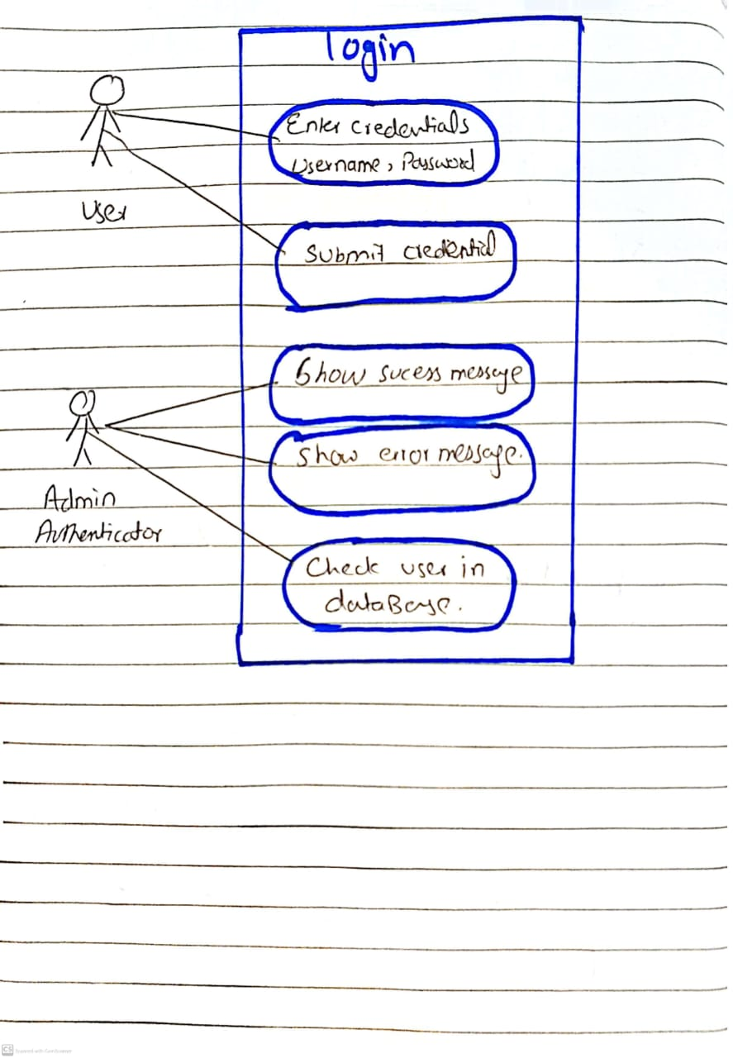

**Class diagram**

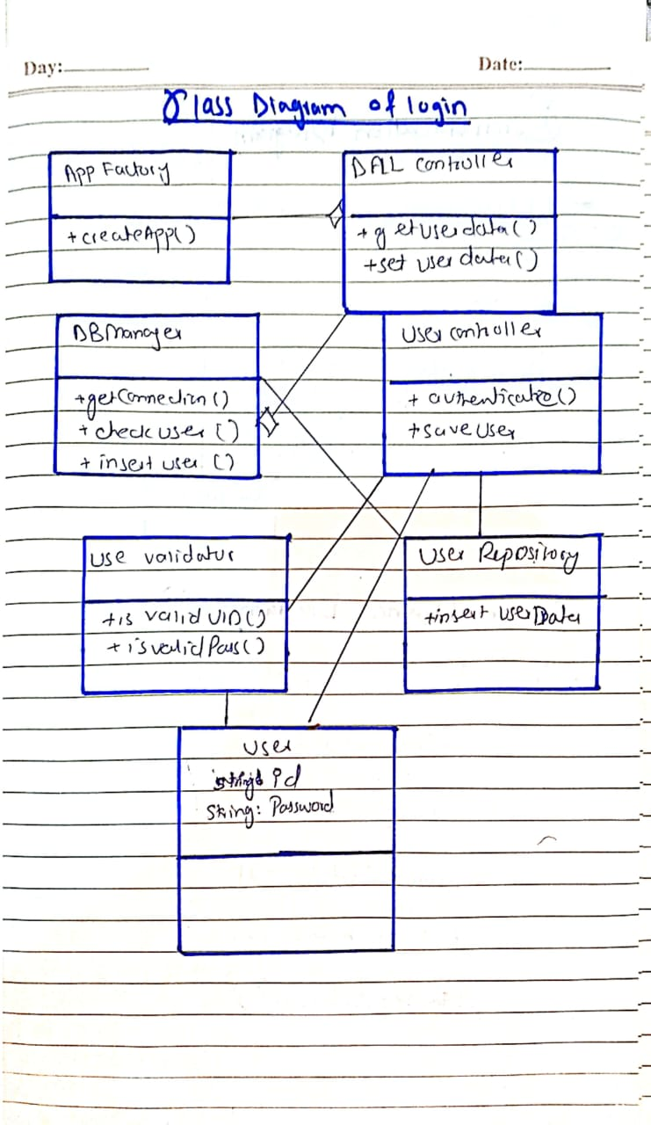

Communication diagram and system sequence diagram

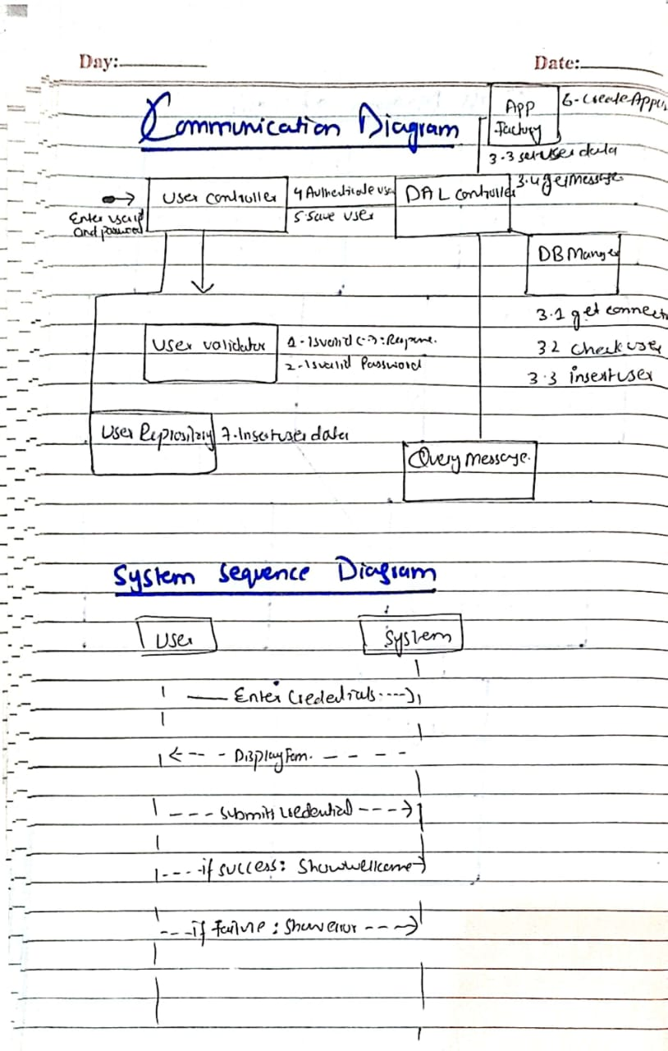

PROTOTYPE

